New Horizons College, Minna

Principal’s End of Second Term Newsletter

Friday 7th April, 2023 (16th Ramadan, 1444AH)

*“Good manners will open doors that the best education cannot." ⁠—Clarence Thomas*

***“There is no gift a parent can give his child that is better than good upbringing” – Prophet Muhammad (PBUH)***

In the name of Allah, the Most Gracious and the Most Merciful.

Assalamu Alaykum Wa Rahmatul’lah Wa Barakatuh

All praises to Allah Lord of the Worlds, the Eternal and the Absoute, the Ever Living and Every Lasting, Owner of all Dominion and Sovereignty.

I extend my heartfelt greetings to you and your families as we welcome the holy month of Ramadan. May this blessed month be filled with spiritual growth, compassion, and unity for all of us.

For many of our students, this was the their first experience in writing exams and observing the Fast, and it was quite challenging for quite a few of them. On our own part, we gave their leaders the liberty to re-arrange their schedules to what would work best for them.

One of the things we did with the students was to celebrate the coming of the Ramadan, by having them decorate their rooms and hostels with lights and other crafts, and engage in other Islamic oriented activities as our own way to imbibe the spirit of Ramadan; as they come home to you, we kindly request your support in reinforcing the importance of Ramadan in your children's lives, encouraging them to participate in acts of worship, charity, and reflection. By working together, we can instill a deeper understanding and appreciation of this holy month and its teachings in the hearts of our students.

Once again, I wish you and your families a blessed and prosperous Ramadan and Eid Mubarak in advance. May Allah (SWT) accept your fasting, prayers, and good deeds, and shower His countless blessings upon you.

Below are the highlights of this Newsletter:

1. Calendar for 3rd Term
2. GCE Results
3. School Fees
4. Communication
5. Hostel Information
6. Resumption From Election Break
7. **Abridged Calendar For 3rd Term**

Saturday 29th April - Boarders Resume

Monday 1st May - Day students Resume/Lesson Begins.

Saturday 3rd June - PTA General Meeting/ Visiting Day

Saturday 24th June - Vacation for Eid Adha Break

Saturday 8th July - Resumption from Eid Adha Break

Saturday 29th July - Prize Day/ Vacation

Saturday 16th Sept. - Boarders Resume for New Session

Saturday 23rd Sept. - New students’ resumption

1. **GCE Oct/Nov GCE Result for Class of 2023**

We received the Oct/Nov GCE 2023 result with mixed feelings in one or two subject results and excitement regarding other subject results. Briefly, when we compare the Jan/Feb GCE 2022 result and that of Oct/Nov 2022, we see the following:

* The performance of English Language of October/November 2022 was not as sound as that of January/February 2022.
* Mathematics is still work in progress; there appears to be stability for movement forward.
* Economics results have significantly improved.
* There was marked improvement in Chemistry, Physics and Biology.
* Subjects like IRS, Geography, Food & Nut, Financial accounting, and others have been consistent.

It is worth noting that getting our students to write the GCE is usually an opportunity to assess our student's preparedness for WAEC in June. Hence, we have analyzed and come up with strategies to help those with deficiencies. Here is what we are doing or have done:

* *Each teacher has drawn up a personal plan for each student that failed in his or her subject in GCE, as well as based on the students’ performances in Pre-GCE, MOCK and GCE exams.*
* *Such students are being given support lessons by7am in the morning and are now in the process of solving past questions for the past10-15 years.*
* *Students who obtained Pass grade or failed key subjects like Maths, English, etc., have been given the same GCE question to write under exam conditions. Their scripts have now been marked according to WAEC standard, after which their results will be analyzed, to see where each student needs further support.*

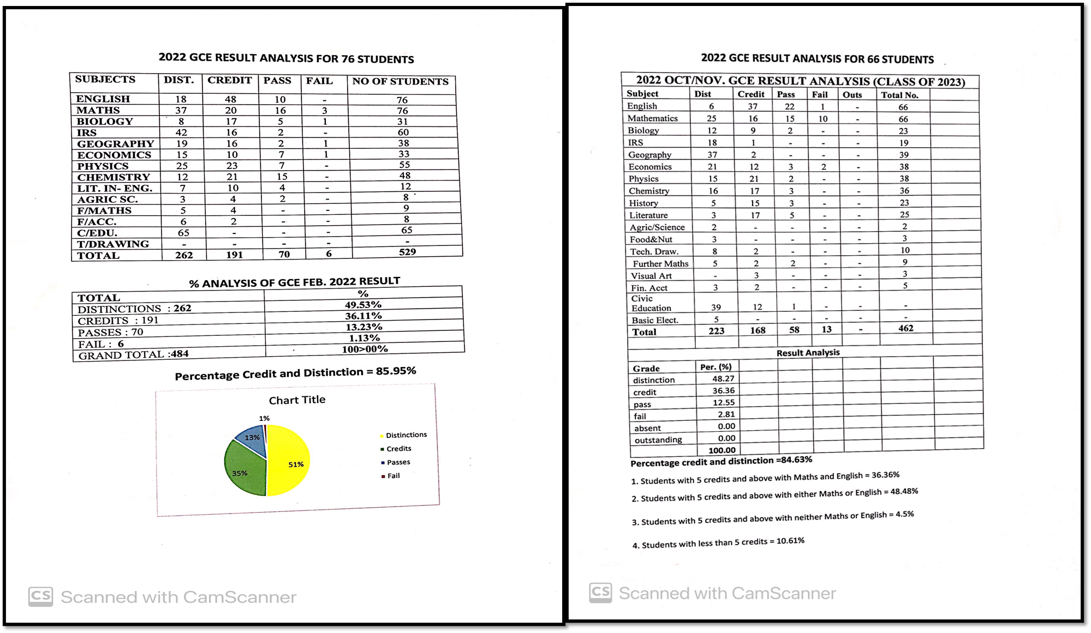

1. **School Fees Increase**

The cost of running a school has significantly increased in recent times, due to various obvious factors such as inflation, rising utility costs, and other operational expenses.

While we have done our best to minimize costs and maintain affordable fees, the reality is that our current fees are no longer sufficient to cover our expenses and sustain the quality of education we provide.

As a result of this reality, the school carried a deficit of N45 million into this session, which we shared into the three terms of this session in the order of 15 million each for first, second and third terms. This means we had less for budgeted expenditure for each term by the amount stated above!

The reason being, items such as diesel, NEPA bill, food, text and exercise books, stationaries, high maintenance of equipment and machines, drugs and diagnostic tests, hospital visit bills, and other items and services we subscribe to, have all gone up by 50%-150%! Hence, the need to revisit the amount students pay for school fees to ensure that we continue to provide competitive education and other services in the conducive environment our students are used to.

When we looked at the actual expenditure for first and second terms of the current session in addition to the projected expenditure for third term, the minimum projected school fees increase would have to be a 50% increase of school fees for the school to break even financially. Unfortunately, the salaries of parents have not increased, and many of the businesses of parents have also been affected by the covid-19 pandemic and harsh economic climate; hence, the need to find a win-win situation for both the school and parents.

After playing around with the numbers, a 30% increase in school fees was chosen after the resulting deficit (difference between projected income from school fees and other sources against projected expenditure) was brought down from N90million plus to N16million! We are currently in talks with our headquarters, IET, to help with fund raising to take care of the deficit.

Out of consideration of the present reality, the school will be offering parents who may need some sort of relief, a payment plan of a maximum of three payment spread over each term based on request in writing. If a parent has no history of violating previous letter of undertaking, such a family will be eligible.

Lastly, we plan to offer discounts to parents who have at least three children in the school based on character and conduct of each child, and this is subject to review every year; the discount will be 10% per child.

Once again, we appreciate your understanding and continued support as we strive to provide the best possible education for our students. We are confident that these changes will enable us to sustain our high standards and help our students achieve their full potential.

Thank you for your ongoing commitment to the progress of the school and the future of our children.

Please find the new fees schedule for both day students and boarders below:

**For Boarders:**

OLD FEES NEW FEES

659,875 (1ST TERM) 860,000

555,500 (2ND TERM) 725,000

555,500 (3RD TERM) 725,000

1,770,875 2,310,00

**N.B: These includes the security and ICT levies. (SS2-3 will not have ICT levy)**

**For Day students:**

OLD FEES NEW FEES

355,195 (1ST TERM) 465,000

210,815 (2ND TERM) 275,000

210,815 (3RD TERM) 275,000

776,825 1,009,874

**N.B: These includes the security and ICT levies. (SS2-3 will not have ICT levy)**

**4. Communication**

As we strive to keep you informed about your child's progress, school events, and essential updates, we acknowledge that we have not met your expectations in this regard. We have identified the areas where our communication has been insufficient or unclear and are committed to taking immediate action to rectify these issues. Consequently, we have taken the following measures:

* Created WhatsApp chat groups for parents based on the class of their child.
* Shared on all the class WhatsApp platforms the phone number of the Registrar 08052662218, that of the Assistant Registrar 08093957509, and school landline 08062218664.
* Ensure information is passed to parents in a timely manner.
* Registrar to be more forthcoming in responding to messages and missed calls from parents.

Once again, please accept our heartfelt apologies for the communication issues you have experienced. We are grateful for your understanding, patience, and continued support as we work to strengthen our communication and better serve parents

1. **Hostel Information**

It has come to our attention that some students are bringing large-sized boxes or containers to the hostel, which occupy significant space in their rooms and cause inconvenience to their roommates.

Our priority is to ensure a comfortable and safe living environment for all our students in the hostel. To achieve this, we kindly request your support in adhering to the following guidelines when preparing your child's personal belongings for the upcoming term:

* Please ensure that the size of any boxes your child brings to the hostel does not exceed an average size box similar to Hajj and Umrah luggage specification. This will help maintain adequate space in the rooms and prevent overcrowding.
* Encourage your child to pack only the necessary items they will need for daily use, including clothing, toiletries, study materials, and a few personal items for leisure. This will help reduce the overall volume of belongings in the room.

1. **Resumption From 2nd Term Break**

Students are expected to resume from the break on Saturday 8th April 2023, on or before 5pm. If any unavoidable circumstance arises to hinder the resumption of your child, please call ahead to notify the School Registrar on 08052662218 or 08093958767.

As we reach the conclusion of another successful term, I would like to take a moment to express my sincere gratitude and appreciation for your unwavering support and involvement in our school activities and affairs. Your dedication to your children's education and well-being has greatly contributed to the progress and growth we have seen in our students this term.

Wassalamu alaykum

Mustafa Mas’ood

Principal